Gemini Supercomputer Interconnects

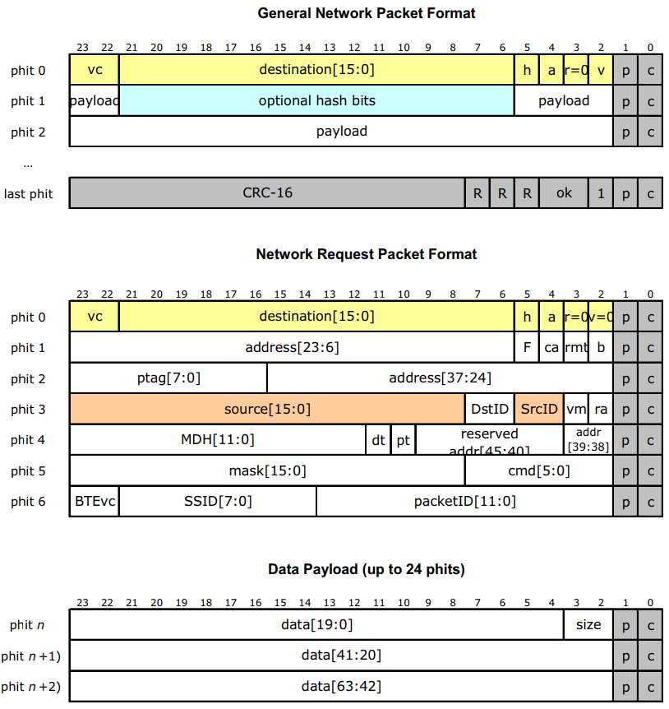

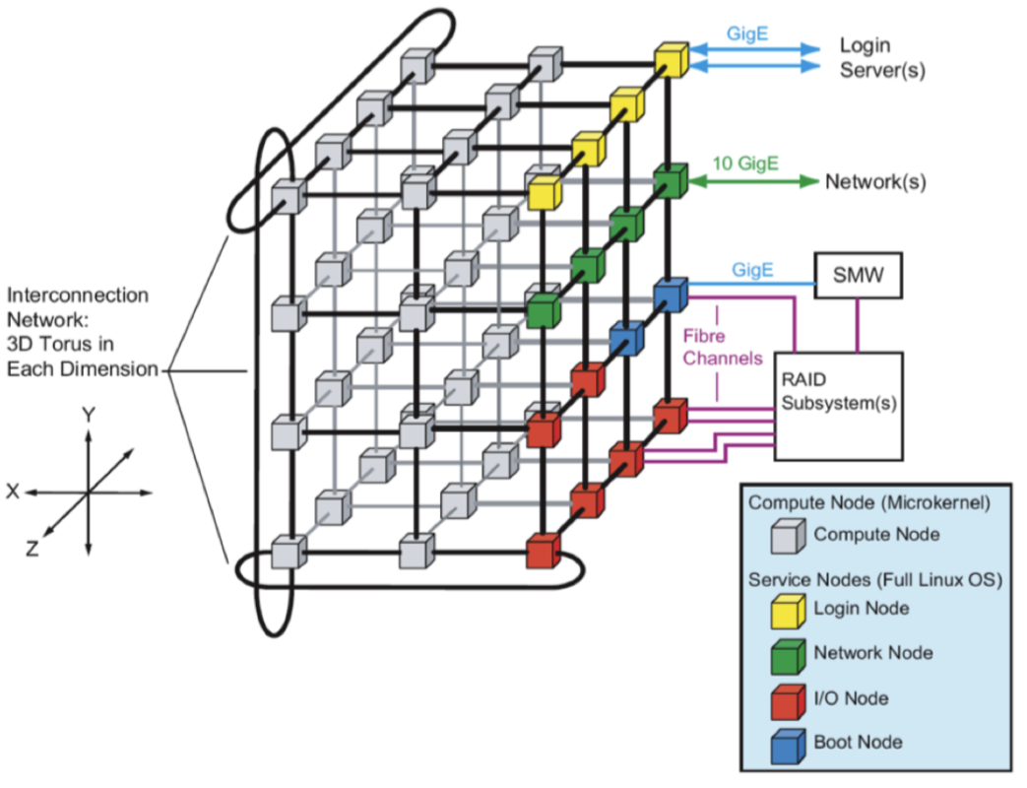

Gemini network topology: 3D Torus

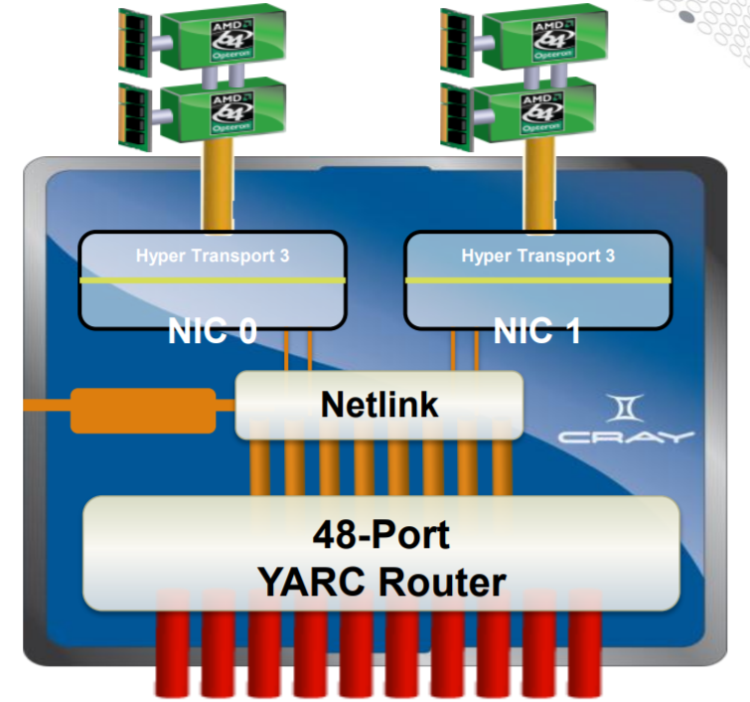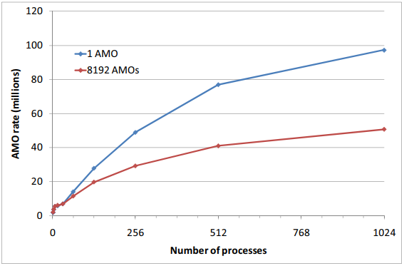

Performance

* (right) number of Atomic Memory Operations per second based on number of processes (with caching in blue and without caching in red)
* (bottom left) latency of memory operations based on type and size of message
* (bottom right) bandwidth of links based on size of messages and number of Processes Per Node